Quantum physics

* Wave Nature of particles
  + We have thus far developed a model of atomic structure based on the particle nature of matter:
  + Atoms have a dense nucleus of positive charge with electrons orbiting the nucleus in rather peculiar quantum orbits. Electrons are thus negatively charged particles. Or are they?…
* DeBroglie wavelength
  + DeBroglie hypothesis
    - De Broglie postulated that in analogy to light, matter could also have particle and wave characteristics.
 $E=mc^{2}=KE+m0c^{2}$     * Where E represents relative energy equation by Albert Einstein which implies that the energy of a body is its mass multiplied by the speed of light
      * De Broglie hypothesized that this energy was also equal to KE standing for kinetic energy and m0c2 being the resting mass energy
      * standing for electon momentum
      * standing for wavelength
      * standing for energy
      * standing for Planck’s constant
        + Planck’s constant relates to the energy in one quantum also known as photon of electromagnetic radiation to the frequency of that radiation
      * $f$ standing for frequency
 $λ=\frac{h}{p}$     * DeBroglie wavelength
  + 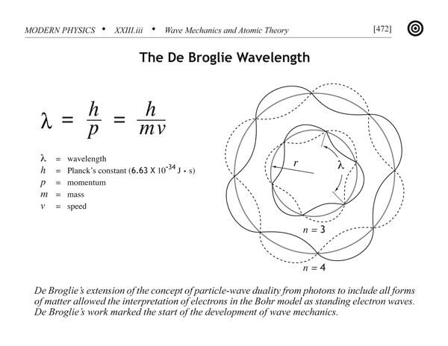Diagram:
* DeBroglie wavelength and the bohr atom
  + De Broglie’s matter wave provided an explanation of the quantization of angular momentum in the Bohr atom. Waves travelling in opposite directions in a confined space can set up a standing wave due to constructive interference. A standing wave in a circle is formed when an integer number of wavelengths fits around the circumference:
  + Angular Momentum Quantization

|  |  |
| --- | --- |
| **Topic** | Quantum physics research |
| **Subtopic** | DeBoglie wavelength |
| **Concept Name** | The debroglie wavelength and its equation |
| **Description** | De Broglie postulated that in analogy to light, matter could also have particle and wave characteristics. |
| **Formula** | * + Where E represents relative energy equation by Albert Einstein which implies that the energy of a body is its mass multiplied by the speed of light   + De Broglie hypothesized that this energy was also equal to KE standing for kinetic energy and m0c2 being the resting mass energy   + standing for electon momentum   + standing for wavelength   + standing for energy   + standing for Planck’s constant     - Planck’s constant relates to the energy in one quantum also known as photon of electromagnetic radiation to the frequency of that radiation   + standing for frequency $λ=\frac{h}{p}$ |
| **Drawing/Animation** | http://wikipremed.com/01physicscards600/472a.gif |
| **Relevant Tags** | Hashtag all relevant topics discussed in this module (e.g. #forces #gravity #acceleration) |

|  |  |
| --- | --- |
| **Topic** | Quantum physics research |
| **Subtopic** | DeBroglie wavelength |
| **Concept Name** | Quantizized angular momentum and the bohr atom |
| **Description** | De Broglie’s matter wave provided an explanation of the quantization of angular momentum in the Bohr atom. Waves travelling in opposite directions in a confined space can set up a standing wave due to constructive interference. A standing wave in a circle is formed when an integer number of wavelengths fits around the circumference: |
| **Formula** | * + standing for wavelength   + standing for Planck’s constant   + m standing for mass   + v standing for velocity   + r standing for radius   + n standing for orbit   + standing for wavelength   + L is only conserved |
| **Drawing/Animation** | https://myweb.rollins.edu/jsiry/Bohr_atom_mode.svg.png |
| **Relevant Tags** | Hashtag all relevant topics discussed in this module (e.g. #forces #gravity #acceleration) |
|  |  |

|  |  |
| --- | --- |
| **Topic** | Quantum physics research |
| **Subtopic** | DeBoglie wavelength |
| **Concept Name** | Davisson-Germer Experiment |
| **Description** | Davisson and Germer showed that electrons do behave like matter waves and can be diffracted. Electrons are reflected from the surface of a nickel target. The surface layer of atoms in nickel acts as a diffraction grating. |
| **Formula** | $2 mv 2 = eV ! v = 2Ve m$ |
| **Drawing/Animation** | http://dev.physicslab.org/img/7230f851-fb87-46d6-ae06-41a587f774c2.gif |
| **Relevant Tags** | Hashtag all relevant topics discussed in this module (e.g. #forces #gravity #acceleration) |
|  |  |

### 

### Matter Waves (but waves matter too)

* Electron diffraction was demonstrated by Davisson and Germer and G. P. Thomson (son of J. J. Thomson).
* Subsequently, diffraction for other matter waves such as atoms, neutrons and even molecules has been demonstrated.
* Atom interferometers can be constructed using standing waves of light as atomic mirrors and beam splitters

DIO

* All matter can have wavelike properties.
* The electron microscope is based on the wave properties of electrons.

|  |  |
| --- | --- |
| **Topic** | Quantum physics research |
| **Subtopic** | Heisenberg uncertainty principle |
| **Concept Name** | Minimum uncertainty |
| **Description** | * Our knowledge of conjugate quantities is inherently uncertain. * No matter how good our measuring instruments are we cannot simultaneously know x and p or E and t with complete precision. |
| **Formula** | $Fourier relations.$ $ΔxΔk=\frac{1}{2}$ $ΔωΔt=\frac{1}{2}$* Heisenberg uncertainty principle $ΔpΔx≥\frac{ℏ}{2}$ $ΔEΔt≥\frac{ℏ}{2}$* For Gaussian functions $ΔpΔx=\frac{ℏ}{2}$ $ΔEΔt=\frac{ℏ}{2}$ |
| **Drawing/Animation** | https://myweb.rollins.edu/jsiry/Bohr_atom_mode.svg.png |
| **Relevant Tags** | Hashtag all relevant topics discussed in this module (e.g. #forces #gravity #acceleration) |
|  |  |